FOR IMMEDIATE RELEASE

Contact: Ali Skinner
(518) 605-4497

AGAINST THE ODDS:
Troy Doctor Hits High-Quality Home Run

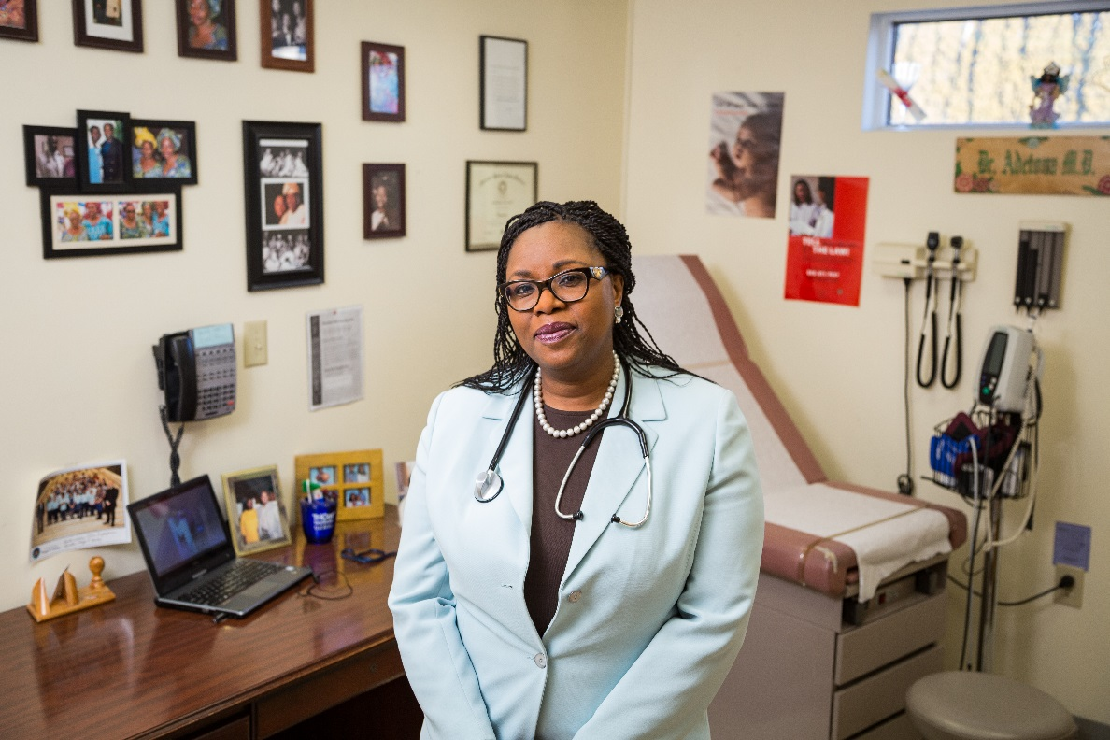

Troy, NY. – Dr. Adetutu Adetona moved to the United States in 1995 to pursue a dream of practicing medicine. Born and raised in Nigeria, she settled in Troy, NY, where she runs the Lansingburgh Family Practice, a 2,000 patient practice whose clientele is primarily Medicaid. With limited resources and a staff of just three employees, Lansingburgh Family Practice has become one of the highest performing primary care practices in the Capital Region.
Lansingburgh Family Practice is one of 200 primary care practices participating in the CDPHP Enhanced Primary Care program, a patient-centered medical home model that rewards doctors for value-based care. Of those 200 practices, Dr. Adetona’s team ranked No. 1 for quality and effectiveness. She says EPC has allowed her to do what she loves: take care of people.

“I moved to America more than 20 years ago. Since then, so much has changed. I have to be very mindful of the cost of my services,” said Dr. Adetona. “A majority of my patients are on Medicaid and will never see a bill, but we are all paying for these costs. I don’t allow myself to get distracted by the latest drug or test. I only prescribe medicine if I think it will help my patients,” Dr. Adetona added.

Launched in 2008, EPC move physicians off of the traditional fee-for service reimbursement model, which encourages more, not better care. Instead, EPC enhances the patient-doctor relationship, as more time is being spent on quality of care rather than quantity.

In 2017, as a result of the program’s success, CDPHP was able to share cost-savings from the program with its EPC practices. In addition to paying practices reimbursements greater than fee-for-services, CDPHP also distributed more than $3 million in bonus payments. The bonuses have allowed EPC practices to make investments in their practices, which in turn, have led to expanded office hours, easier appointment access, electronic communications, and coordinated care.

“I am so very proud of the success achieved by all of our EPC practices, and Dr. Adetona in particular, who has proven that small, independent practices can succeed in today’s world of value-based care,” said CDPHP president and CEO, Dr. John D. Bennett. “Dr. Adetona serves some of the most disadvantaged patients, and despite this, has achieved amazing results,” Dr. Bennett added.

A 2014 study of the EPC program showed the program produced an impressive $20.7 million in savings, all while improving the quality of care for hundreds of thousands of patients. In addition to cost savings, the program has also produced impressive quality results, as EPC practices showed significant improvements on a series of quality measures that included breast and colorectal cancer screenings, childhood immunizations, childhood well visits, and more.

The EPC program currently includes 203 primary care practices with over 800 clinicians, delivering primary care services to more than 250,000 CDPHP members. To learn more about EPC, visit www.cdphp.com/care.

About CDPHP®
Established in 1984, CDPHP is a physician-founded, member-focused and community-based not-for-profit health plan that offers high-quality affordable health insurance plans to members in 24 counties throughout New York. CDPHP is also on Facebook, Twitter, LinkedIn, Pinterest, and Instagram.

###

